Bug_01:

White color should not be visible

Bug_02:

Should be more on right side

Bug_03:

Border radius issue
Bug_04:
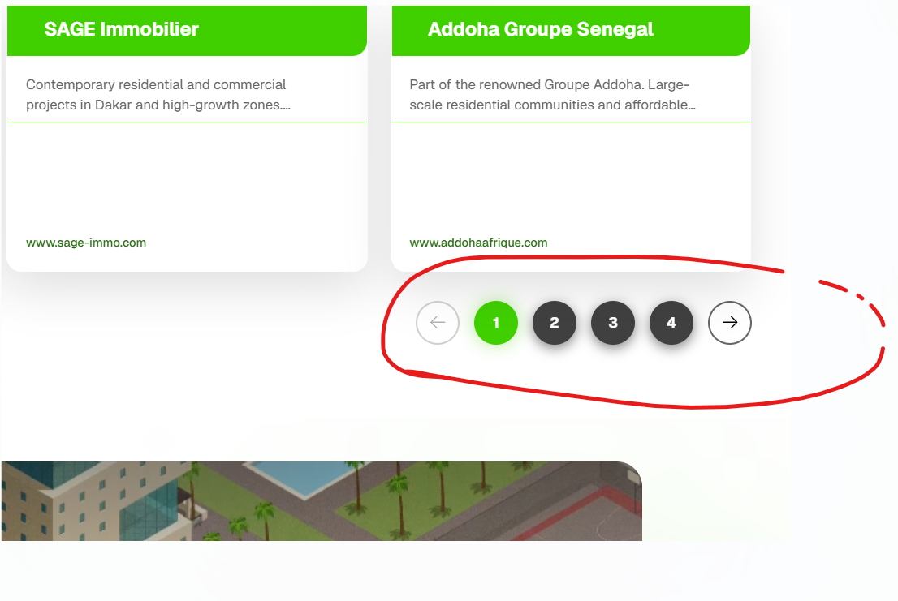
When click on 4 it scroll down and then click on 1,2 it scroll up

